

Installation Document
Oracle 12C version 12.1.0.2 on Linux

Project



DISCLAIMER

This document is strictly private, confidential and personal to its recipients and should not be copied, distributed or reproduced in whole or in part, nor passed to any third party.

Version history
Date | Version | Description | Author
2019-11-20 | 1.0 | Initial Version | Ajithraj Thangaraj

Contents
Version history 3
1. Introduction 5
2. How to Use this Document 5
3. Prerequistes 5
4. Pre Checks 8
5. Grid Installation 11
6. Oracle Installation 42
7. Cluster configuration 57
8. Post Check 58

Introduction

This document describes all the installation process of Grid and Oracle 12C Software for two node RAC starting from scratch on a Linux version 7.6 platform. This document covers all aspect of its installation including all various software’s needed.

How to Use this Document

When Installing the Oracle 12C Software from scratch, Readers are encouraged to follow the order of the document

Prerequistes

Below Pre requests has to be done on the server with help of HCL Unix team before installation.

Packages Installation on 10.200.37.155 and 10.200.37.156
Zip/unzip package
binutils-2.23.52.0.1-12.el7.x86_64
compat-libcap1-1.10-3.el7.x86_64
compat-libstdc++-33-3.2.3-71.el7.i686
compat-libstdc++-33-3.2.3-71.el7.x86_64
gcc-4.8.2-3.el7.x86_64
gcc-c++-4.8.2-3.el7.x86_64
glibc-2.17-36.el7.i686
glibc-2.17-36.el7.x86_64
glibc-devel-2.17-36.el7.i686
glibc-devel-2.17-36.el7.x86_64
ksh
libaio-0.3.109-9.el7.i686
libaio-0.3.109-9.el7.x86_64
libaio-devel-0.3.109-9.el7.i686
libaio-devel-0.3.109-9.el7.x86_64
libgcc-4.8.2-3.el7.i686
libgcc-4.8.2-3.el7.x86_64
libstdc++-4.8.2-3.el7.i686
libstdc++-4.8.2-3.el7.x86_64
libstdc++-devel-4.8.2-3.el7.i686
libstdc++-devel-4.8.2-3.el7.x86_64
libXi-1.7.2-1.el7.i686
libXi-1.7.2-1.el7.x86_64
libXtst-1.2.2-1.el7.i686
libXtst-1.2.2-1.el7.x86_64
make-3.82-19.el7.x86_64
sysstat-10.1.5-1.el7.x86_64
dejavu-sans-fonts-2.33-1.el6.noarch
dejavu-fonts-common-2.33-1.el6.noarch
dejavu-serif-fonts-2.33-1.el6.noarch
dejavu-sans-mono-fonts-2.33-1.el6.noarch
ghostscript-fonts
Add below line in file /etc/sysctl.conf (Kernel parameter setting) on 10.200.37.155 and 10.200.37.156
kernel.shmmax = 4398046511104
kernel.shmall = 1073741824
kernel.shmmni = 4096
kernel.sem = 250 32000 100 128
fs.file-max = 6815744
fs.aio-max-nr = 1048576
net.ipv4.ip_local_port_range = 9000 65500
net.core.rmem_default = 262144
net.core.rmem_max = 4194304
net.core.wmem_default = 262144
net.core.wmem_max = 1048576
kernel.panic_on_oops = 1
Changes in /etc/security/limits.conf on 10.200.37.155 and 10.200.37.156
oracle soft nproc 16384
oracle hard nproc 16384
oracle soft nofile 1024
oracle hard nofile 65536
oracle soft stack 10240
oracle hard stack 32768
grid soft nproc 16384
grid hard nproc 16384
grid soft nofile 1024
grid hard nofile 65536
grid soft stack 10240
grid hard stack 32768
Add below line in /etc/sysconfig/network on e75lrl2038/ e75lrl2039
NOZEROCONF=yes

Create users and groups on 10.200.37.155 and 10.200.37.156

groupadd -g 54321 oinstall
groupadd -g 54322 dba
groupadd -g 54323 oper
groupadd -g 54324 backupdba
groupadd -g 54325 dgdba
groupadd -g 54326 kmdba
groupadd -g 54327 asmdba
groupadd -g 54328 asmoper
groupadd -g 54329 asmadmin
useradd -u 1000 -g oinstall -G dba,asmdba,asmoper,asmadmin,oper,backupdba,dgdba,kmdba oracle
useradd -u 1001 -g oinstall -G dba,asmdba,asmoper,asmadmin grid

Pre Checks

Step 1 : Make sure you have either root password or Oracle account with sudo to root privileges to install cluster software. It ask to enter the password in the middle of the installation.

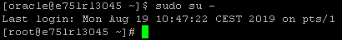

Step 2 : Make sure you are able to ping public ip and private ip between two nodes.
Public IP
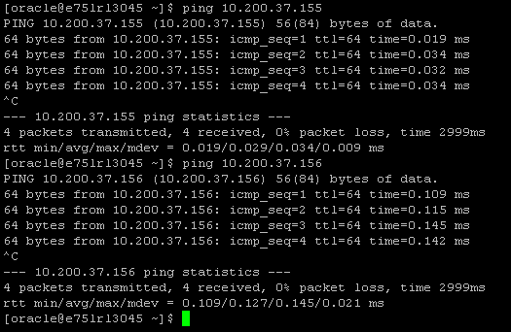

Private IP
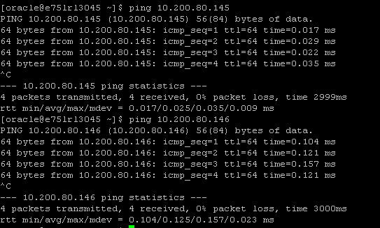

Step 3 : Make sure you see the ASM disk on both the nodes

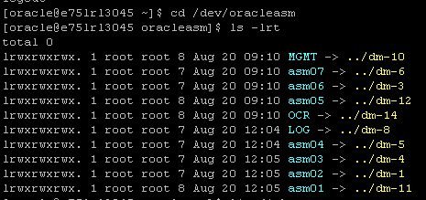

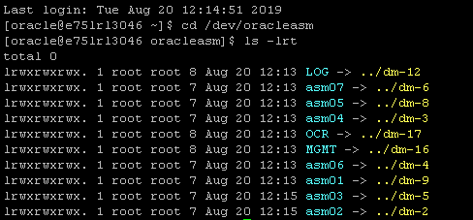

Step 5 : Setup the ssh between two nodes.

./sshUserSetup.sh -user oracle -hosts " e75lrl3045 e75lrl3046" -noPromptPassphrase

Step 6 : Run the cluster verification utility
We can proceed with Grid installation if all the pre request getting verified after running below verification utility.
./runcluvfy.sh stage -pre crsinst -n e75lrl3045,e75lrl3046

Grid Installation

Start the Grid Installation with below command
./gridSetup.sh -applyOneOffs /g01/app/26247490/26247490
Note: Here the Grid Installation is started with bug fixing patch 26247490 - 12.2 ACFS MODULE ERRORS & CRASH DURING MODULE LOAD & UNLOAD WITH OL7U4 RHCK as per oracle recommendation.
- Configuration Option

Choose “Install and Configure Grid Infrastructure for Cluster” and clcik on >>Next
As we are installing cluster
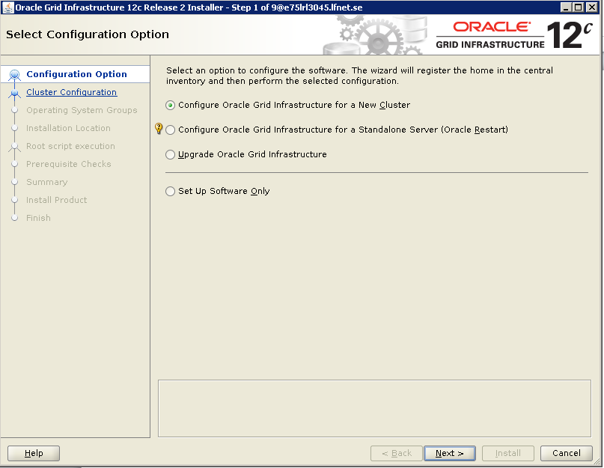

- Cluster configuration
Choose Configure an Oracle Standalone Cluster and click on >>Next

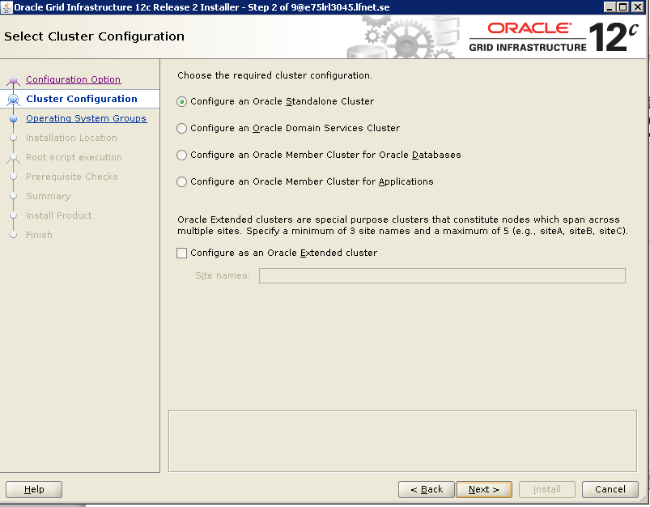

- Grid Plug and Play Information
Give cluster Name as per the environment
Cluster name :PT-CLUSTER
Scan Name : INSISUAT-scan.lfnet.se
Scan Port : 1521
“Uncheck configure GNS”
And click on >> Next
As we are not chooosing on configuring the GNS
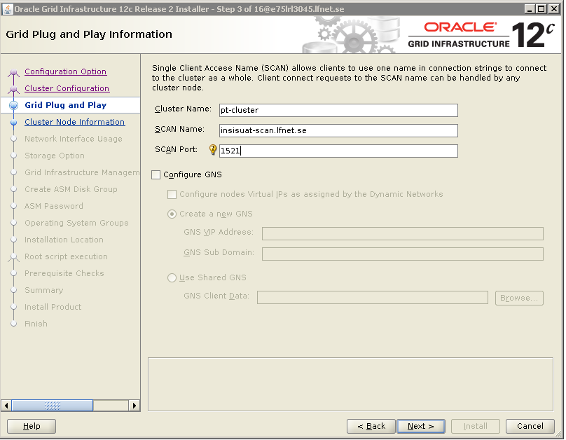
- Cluster Node Information

will prompt you to Add Cluster Node Information
E75LRL3045-vip
E75LRL3046-vip
Click on OK
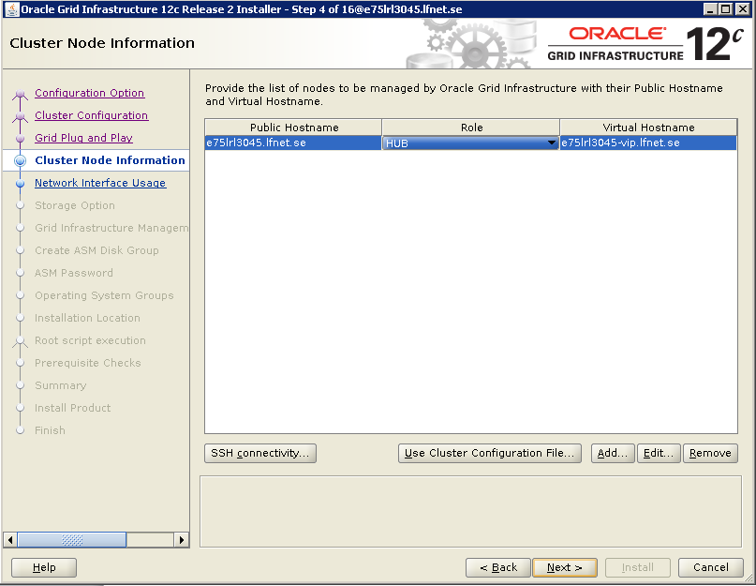
Continuation..

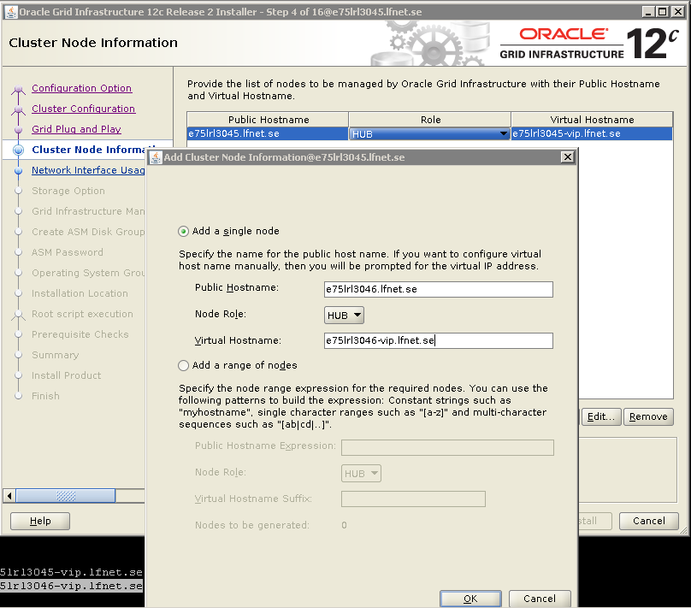

Added Information appears
Check and click on >>Next
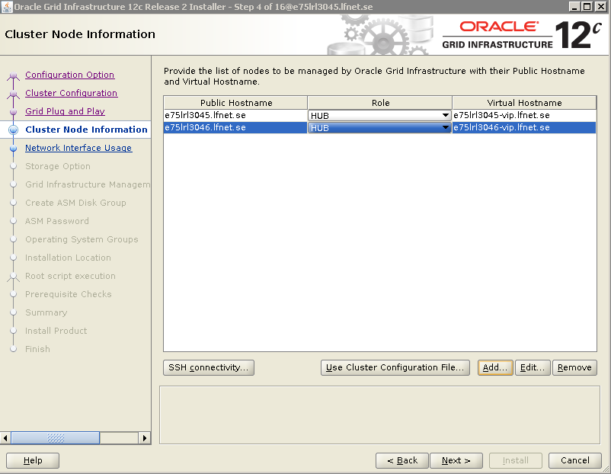

- Check SSH Connectivity
Click the SSH connectivity
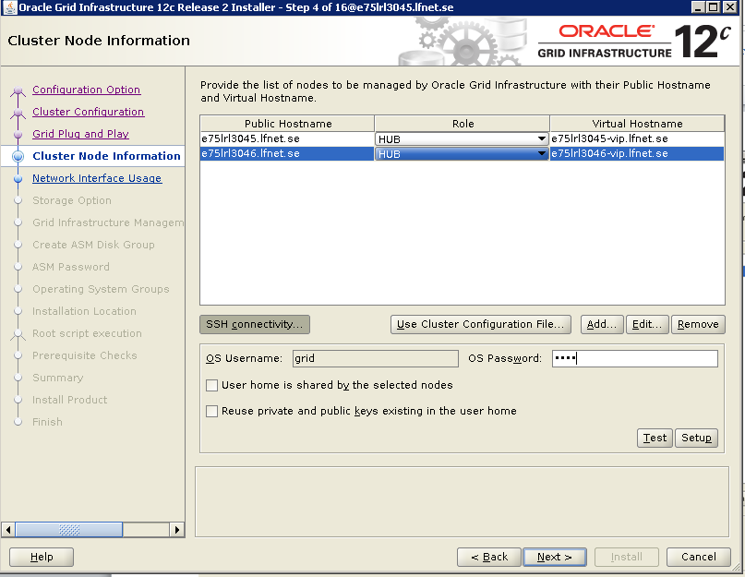

SSH connectivity between the nodes has already established

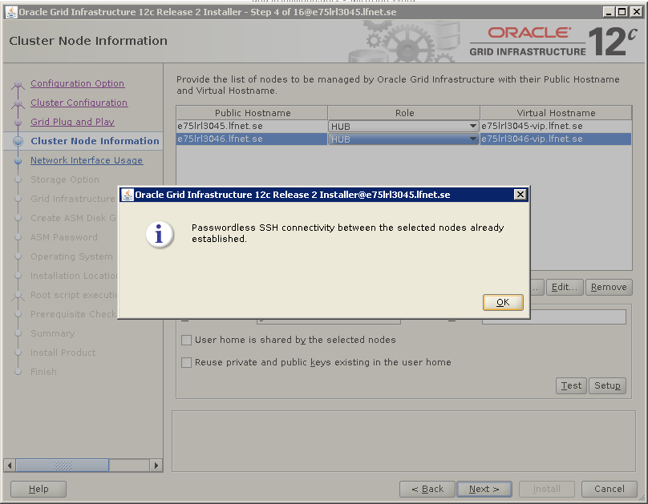

- Network Interface Usage

Change bond0.521 use for Public
Change bond1.1925 Donot use
Change bond2.610 to Private

And click on >>Next
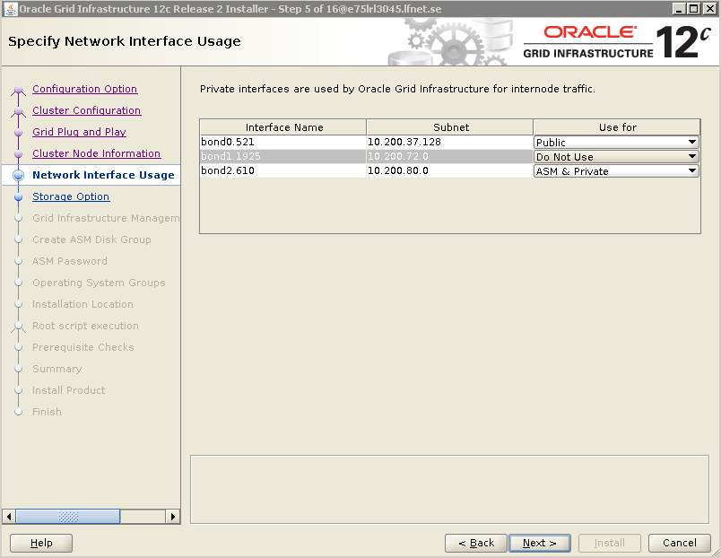

- Storage Option

Choose “Configure ASM using block devices” and click on >> Next

ASM is to configure local Oracle ASM in cluster and store OCR & Voting Disks on it, ASM instance will be configured on all nodes of the cluster

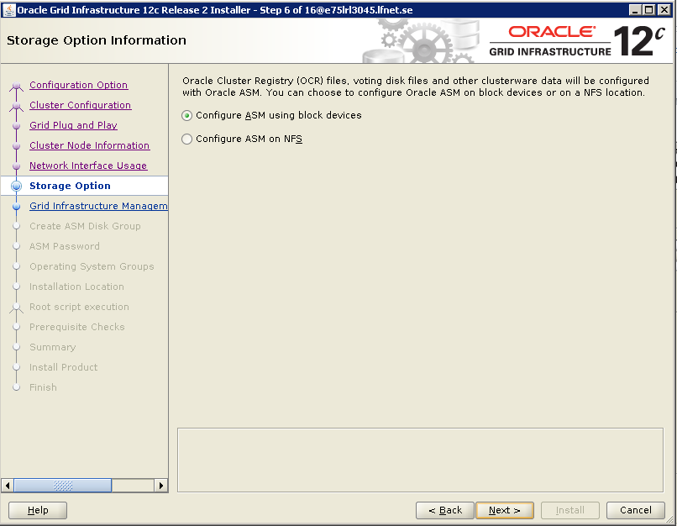

- Creation of ASM Disk Group Data

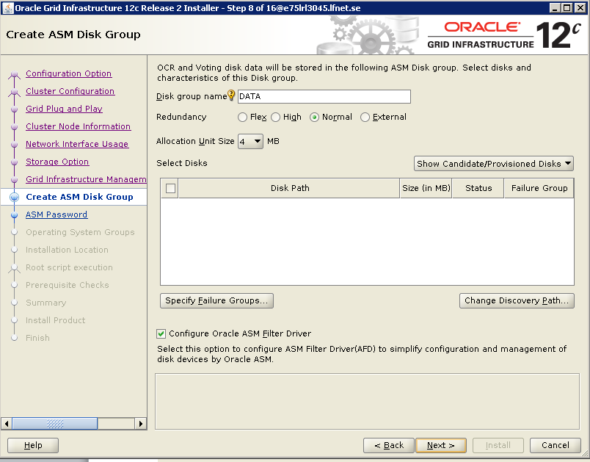

Continuation..

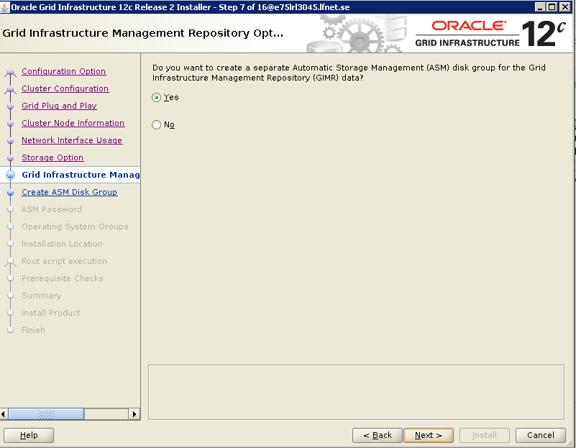

- Creation of Disk Group OCR

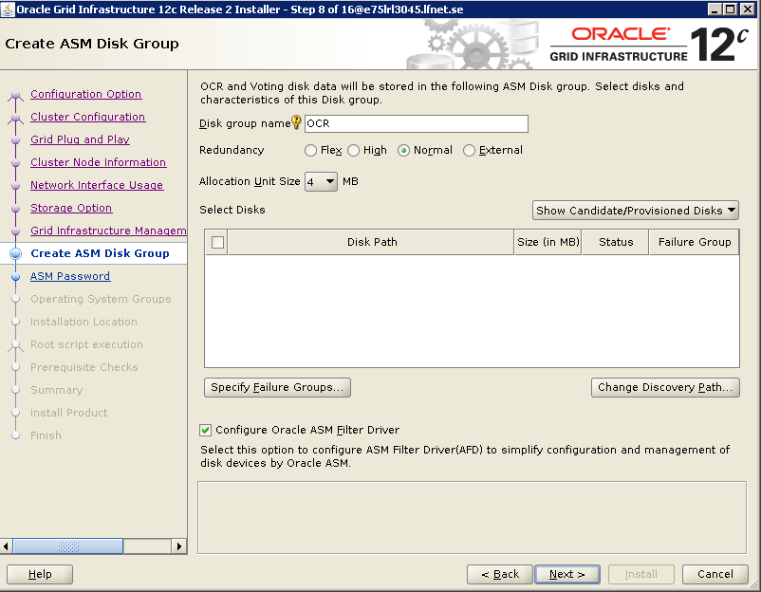

Under “Create ASM Diskgroup” - Disk group name OCR
With Allocation Unit 4 MB
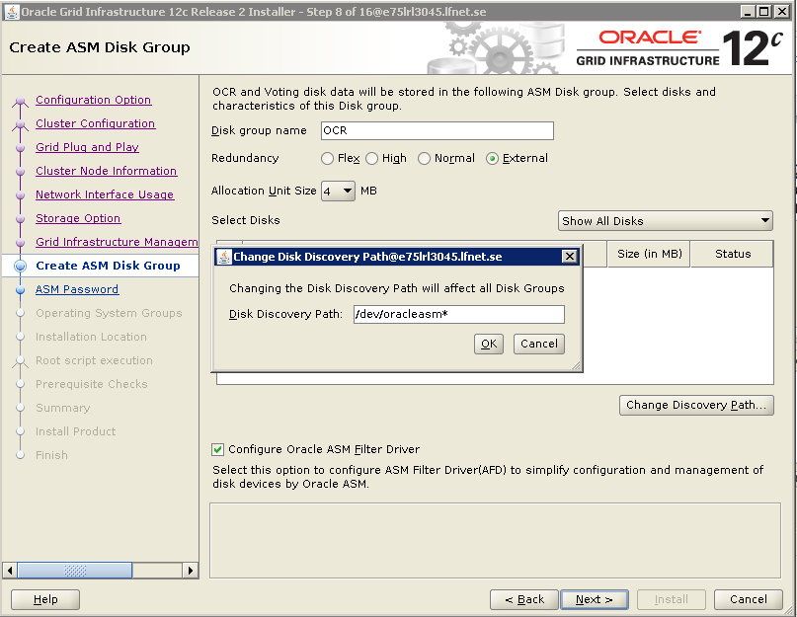

It is the conitinuation from above screenshot
Check “OCR”
And clcik on >>Next

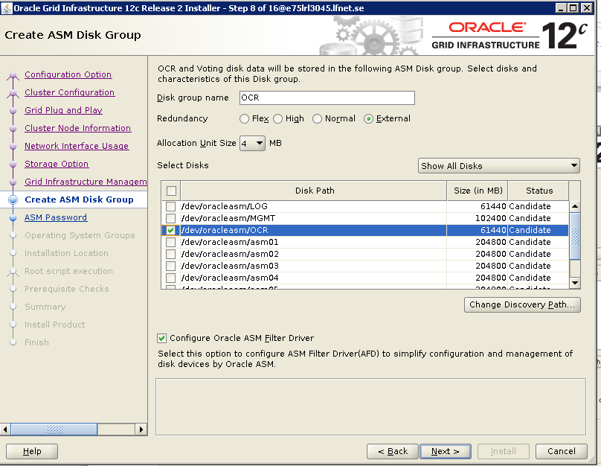

- Creation of Disk Group MGMT

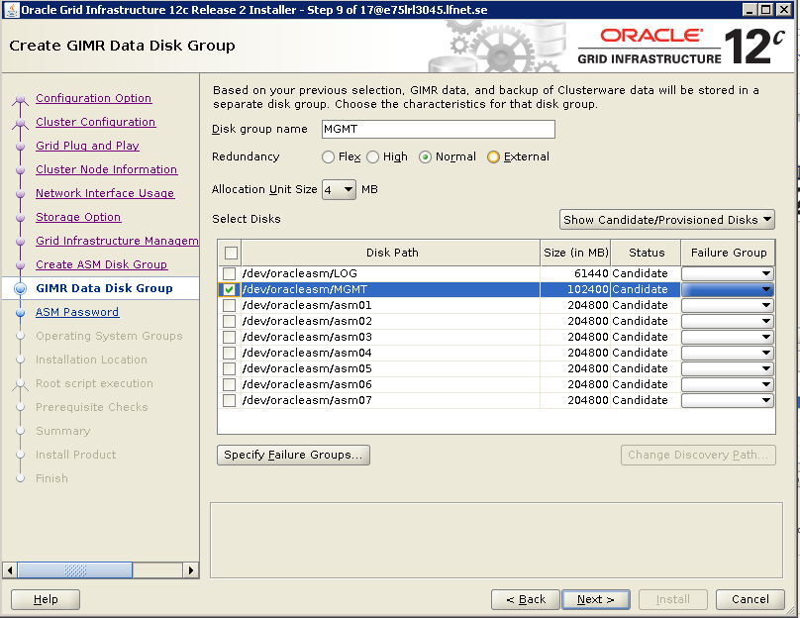

- ASM Password
This Screen allows us to either use the same password or different passwords for SYS and SYSTEM
Choose Use Same Password for these accounts and provide the password (SYS)

(According to our convinient)

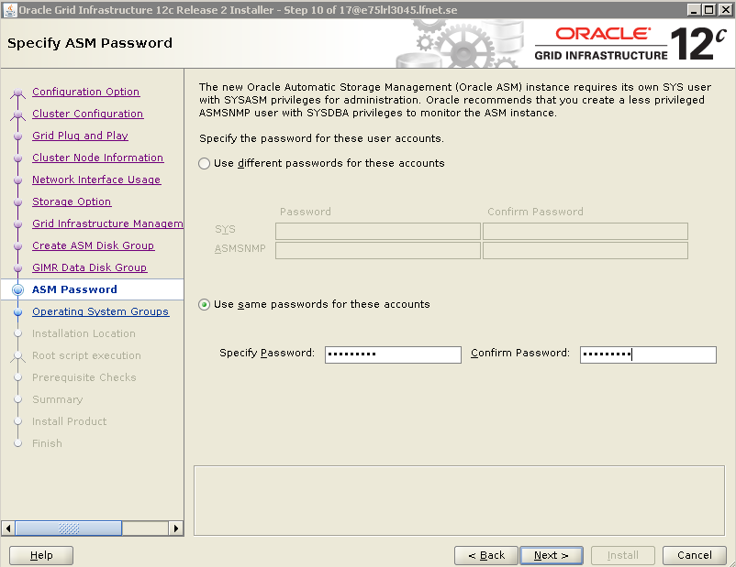
- Failure Isolation
This Screen allows you to either use IPMI Intelligent Platform Management Interface or not to us.
Choose “Do not Use IPMI”
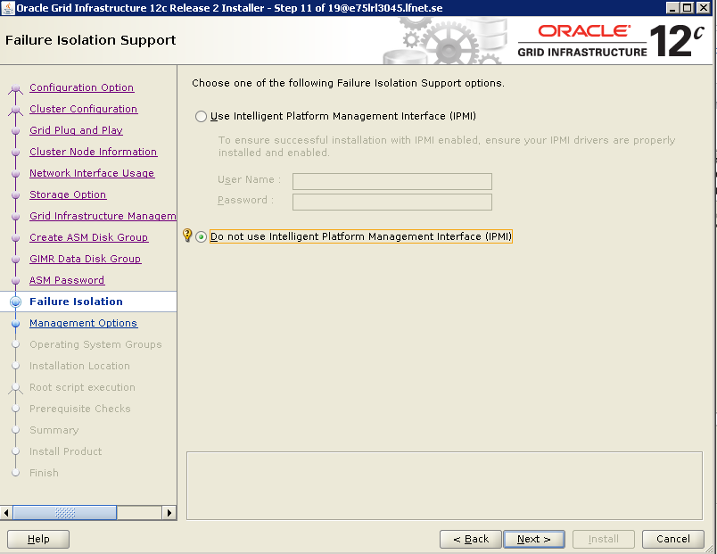

- Management Options
This screen allows you to Register with Enterprise Manager
Uncheck Register with EM cloud control as we donot have EM cloud manager
and click on >>Next

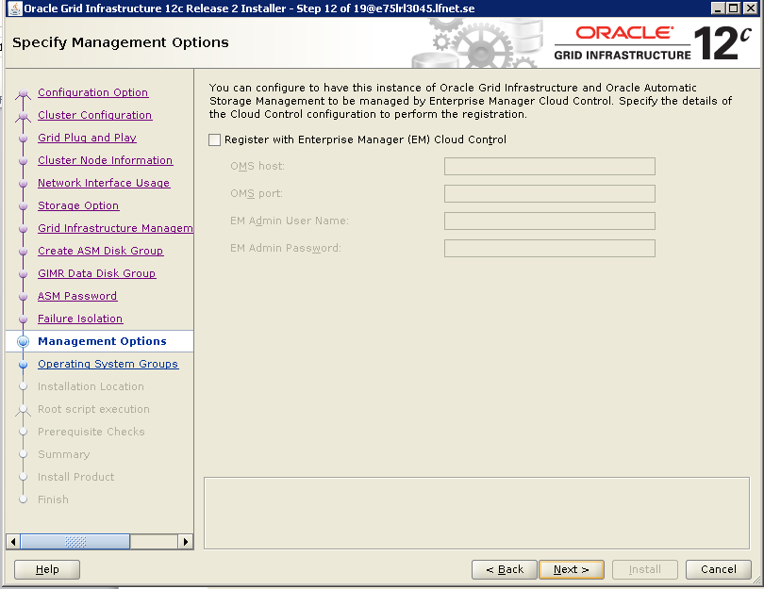

- Operating System Groups
This Screen allows you configure group accounts for Oracle Grid
Choose “asmadmin for ASM Administrator, asmdba for ASM DBA and asmoper for ASM Operator”
And clcik on >> Next
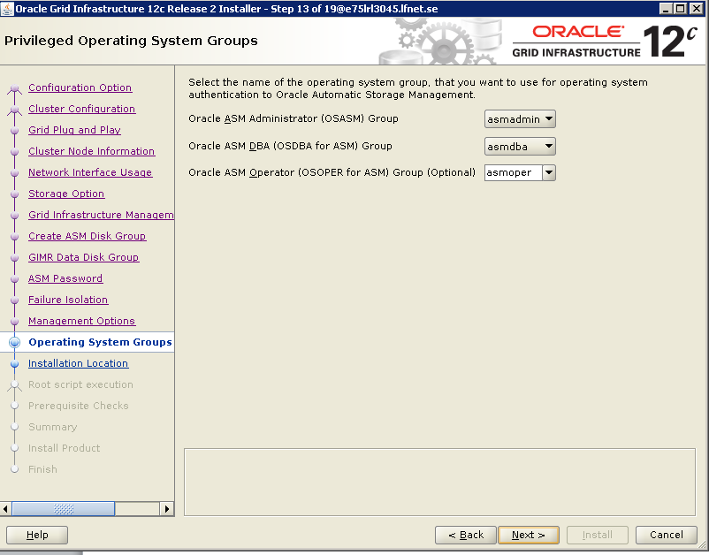

- Installation location

Choose the “Oracle Base : /g01/app/grid/GBase” and “Software Location: /g01/app/grid/Grid12.2”
And click on Next

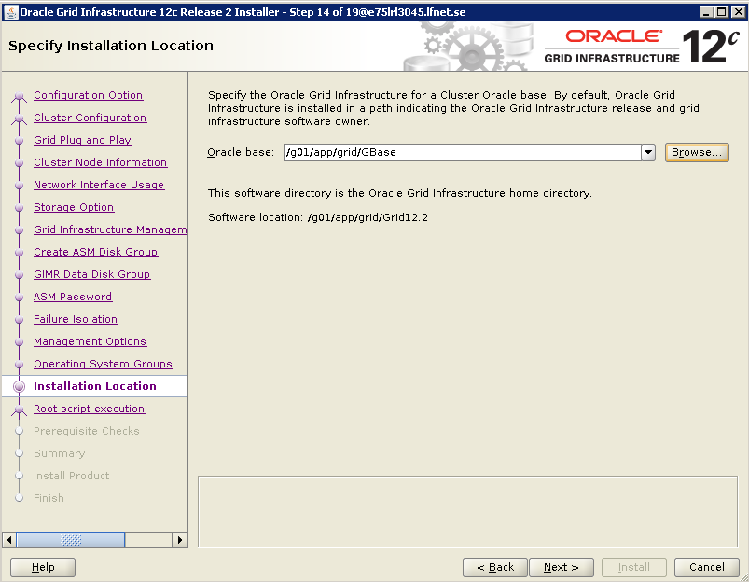

- Root Script execution

Unchek the Automatic run configuration scripts.
And clcik on >> Next
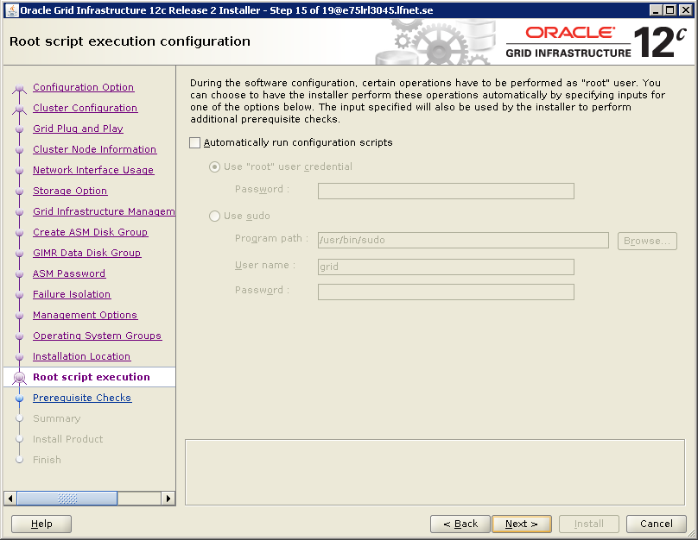

- Verification In Progress
Veriyfing that the tagrget environment meets minimum installation and configuration requirements
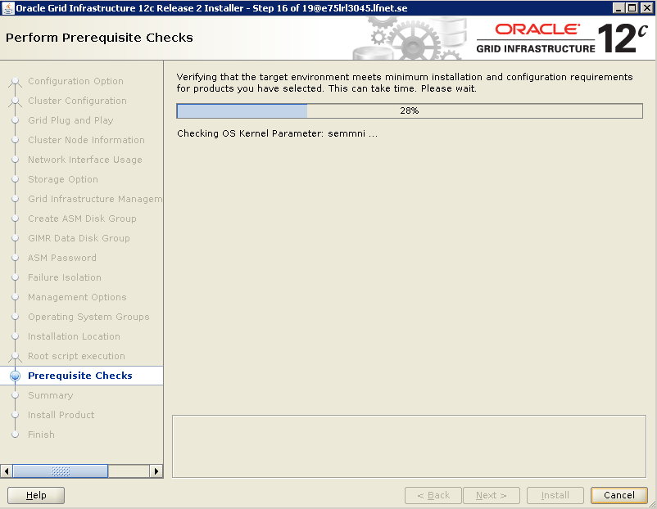

- This Screen shows the verification result.
Review and fixe if any issue is found but listed issue can be ignored, so check Ignore all.
And click on>> Next
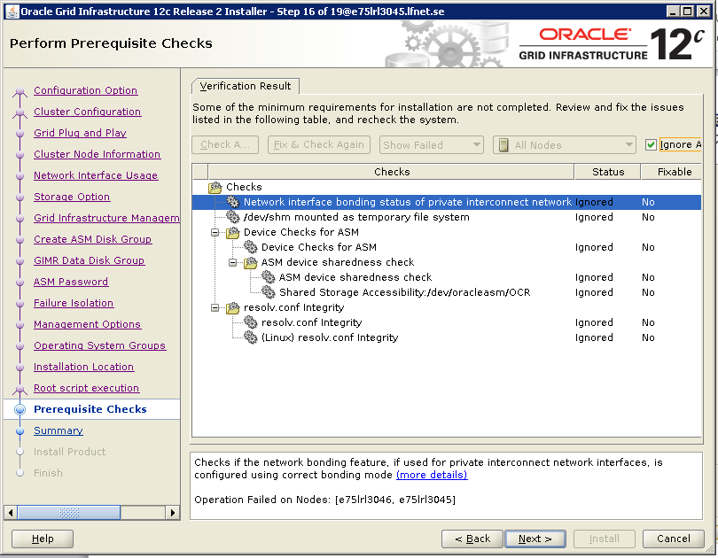

- Summary

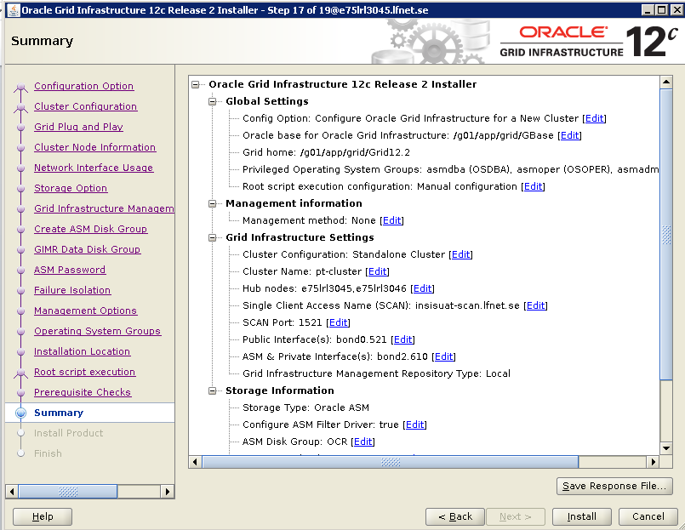

- Run the root script to complete the Grid Installation

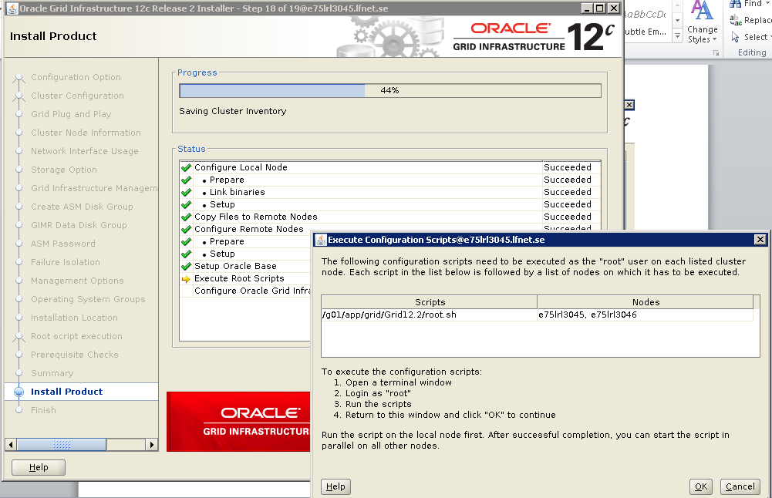

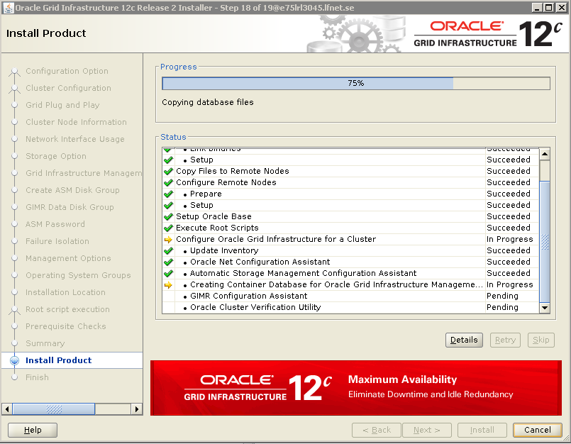

- Grid Installation Completed
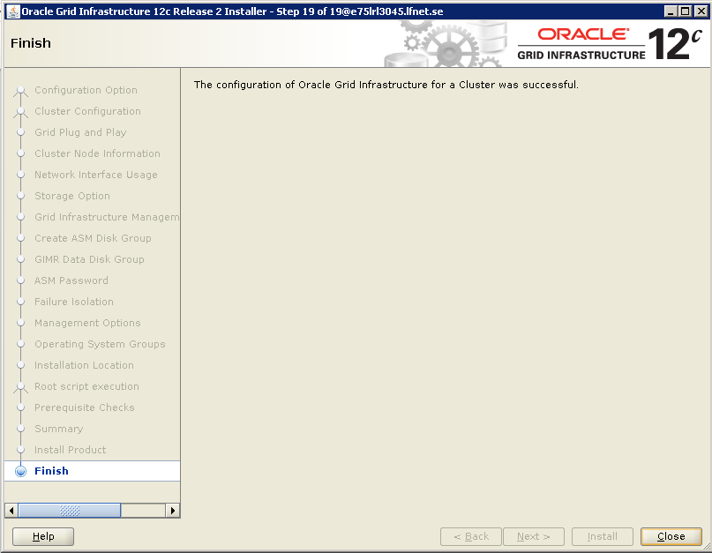

Oracle Installation

Oracle binaries installation has initiated by executing runInstaller
./runInstaller
1. Choose Uncheck to “not receive the security updates”
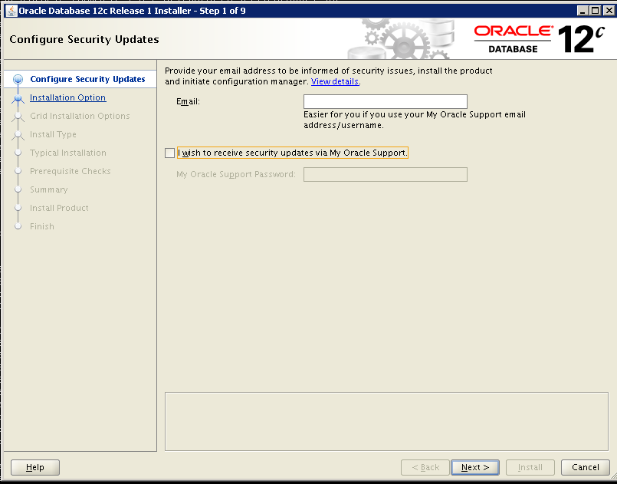
2. Choose “Install Database software only” and click on >> Next
As we are installing the software alone
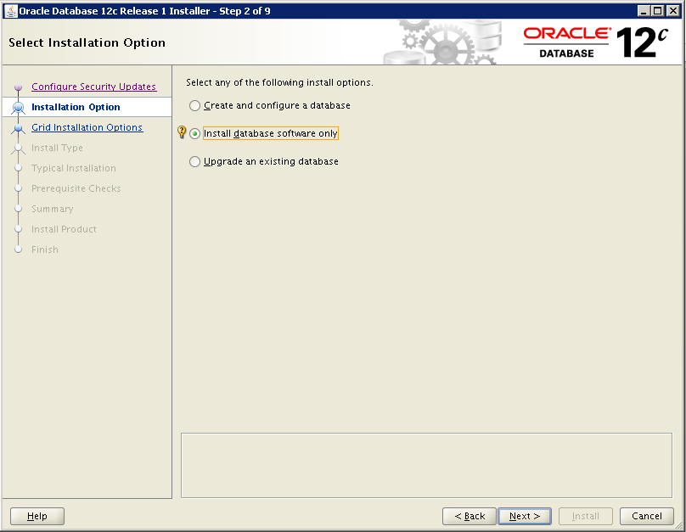

- Under Grid installation options Choose “Oracle RAC database installation” and click on >> Next
As we will configure RAC

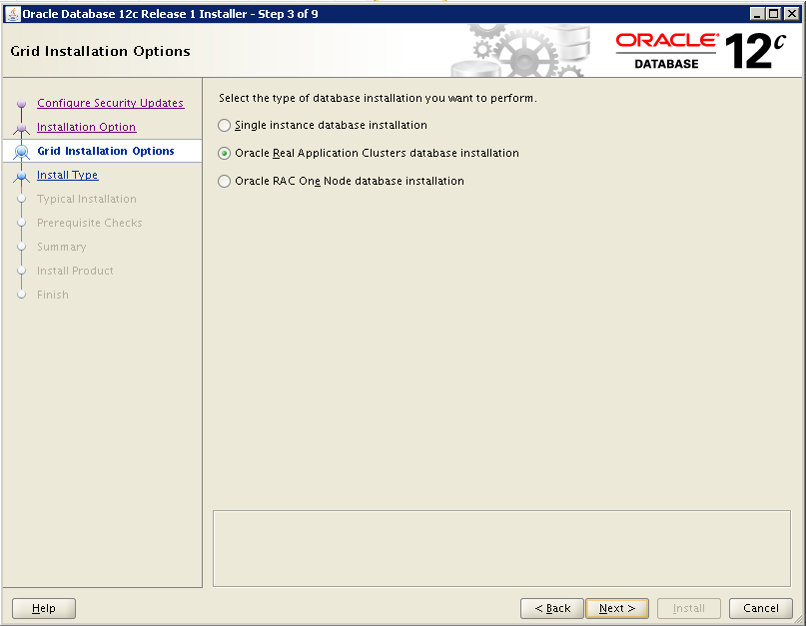

- Under Node Selection Choose “select All” I.e Both the nodes and click on >> Next
As we are configuring 2 node RAC
Establishing SSH connectivity between the selected nodes is in progress.

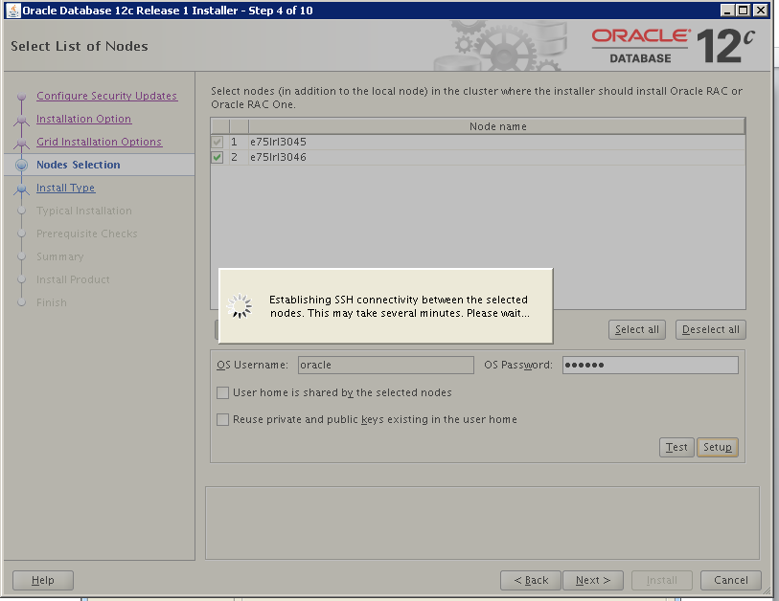

Successfully established the SSH connectivity between the selected nodes

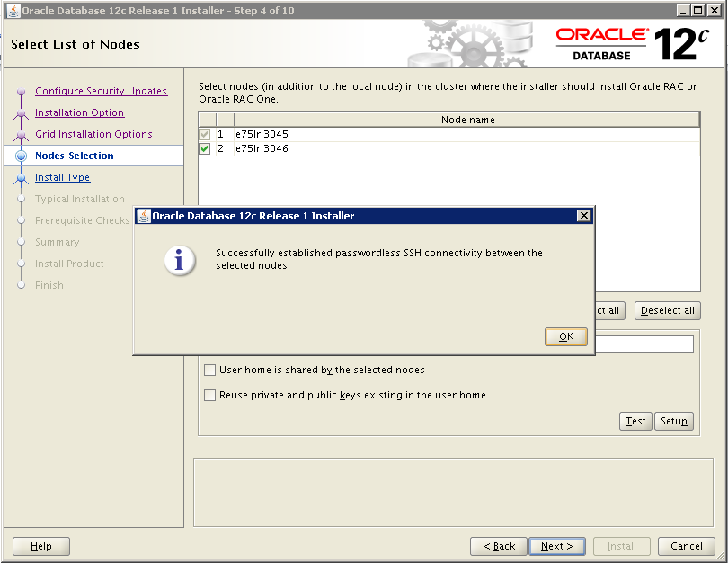

- choose the preferred Language <English> on screen and click on >> Next

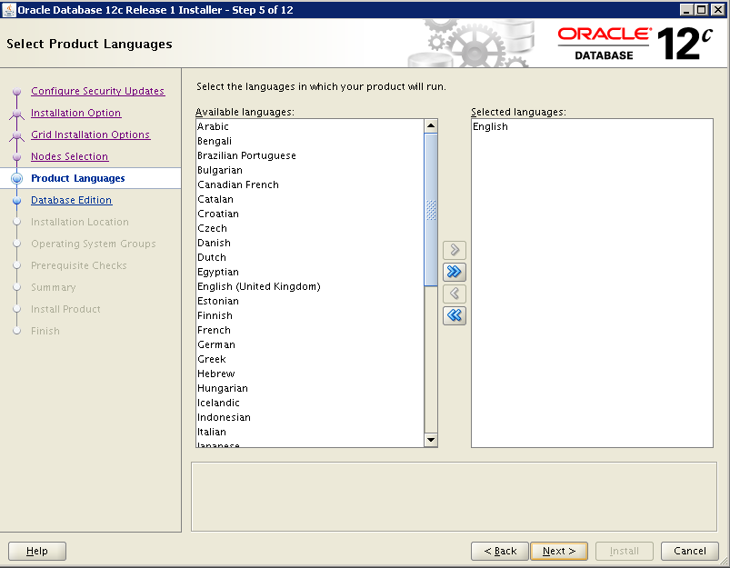

- Choose the database edition as Enterprise edition and click on >> Next

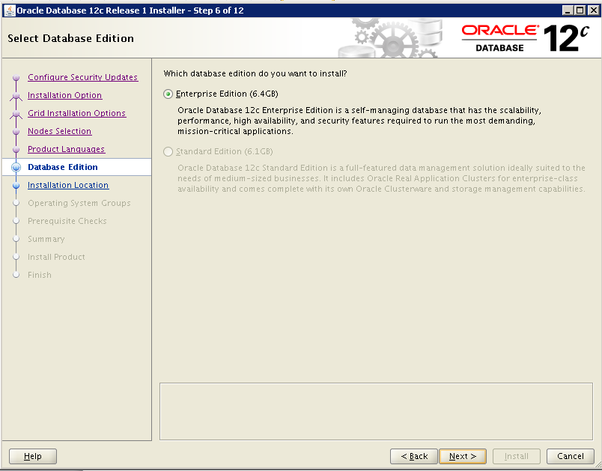

- Specify the Path for Oracle Base and Software location
Oracle base: /u01/app/oracle
Software location: /u01/app/oracle/product/12.1.0/dhhome_1

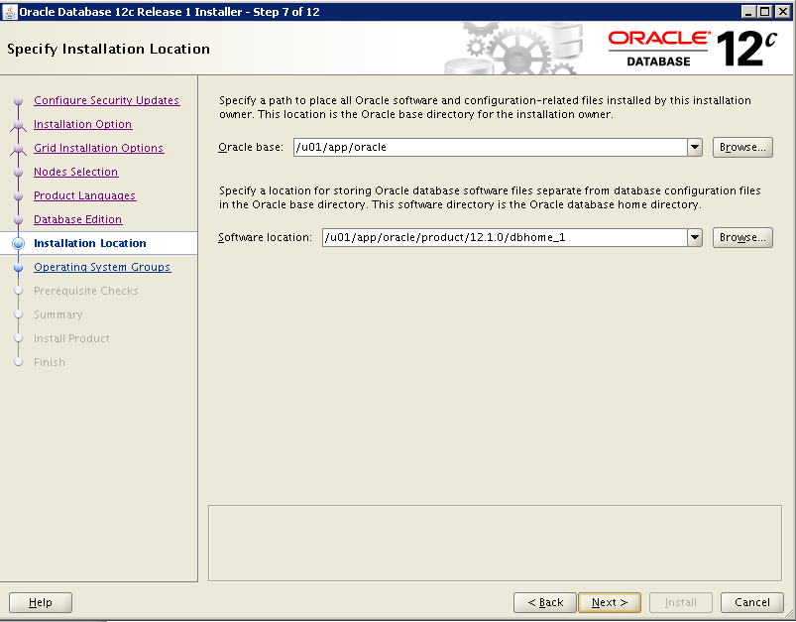

- Choose the Privileged Operating System groups and click on >> next

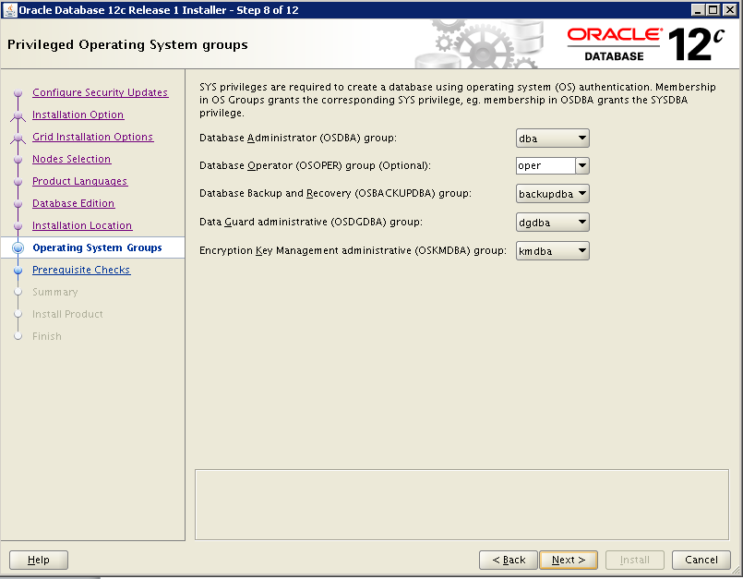

- Proceeds with Verifying configuration and requirements

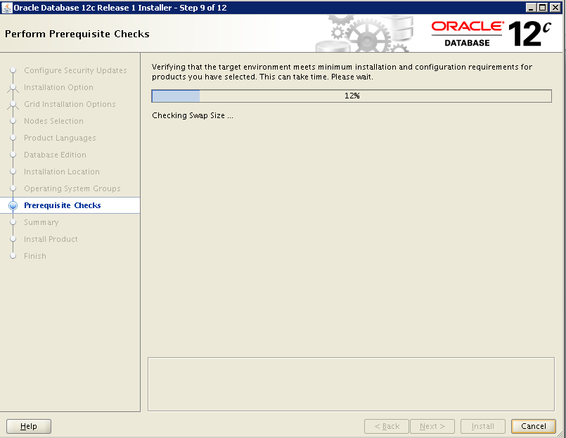

- Ignore the below check as it can be ignored, Click ignore all and click on >> Next

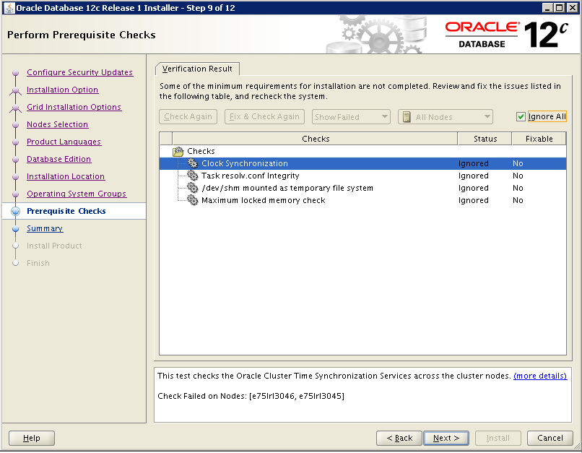

- Summary
Click on >> Install

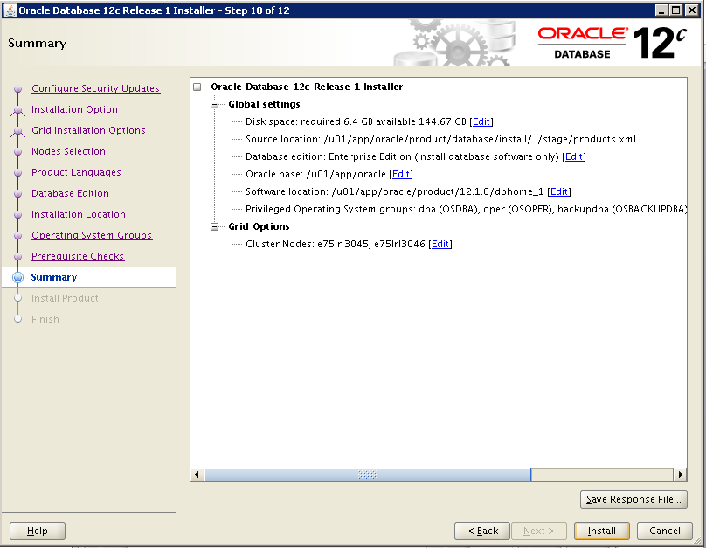

Installation is in Progress

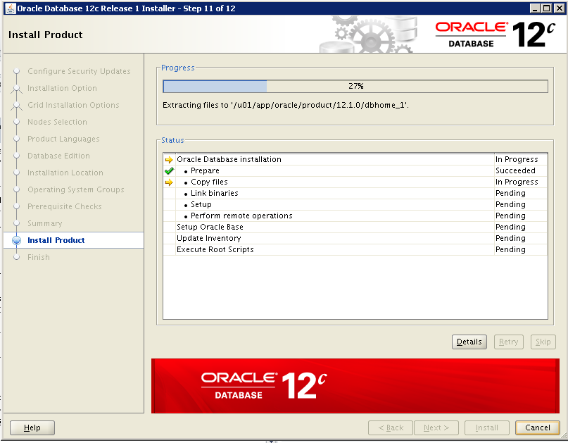

- Run the root script to complete installation

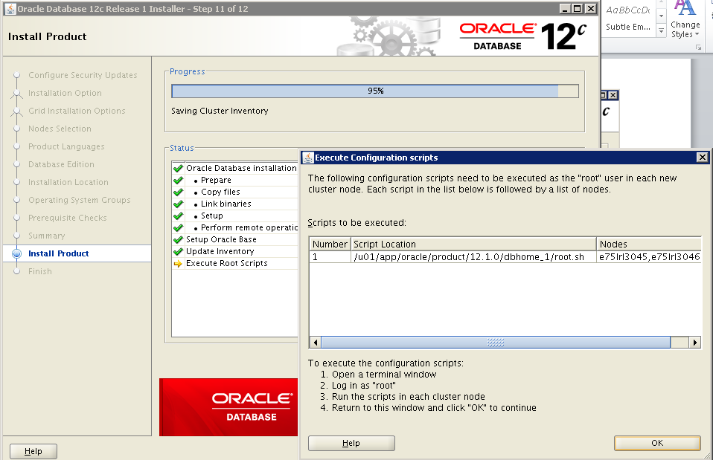

- Oracle Installation Completed.
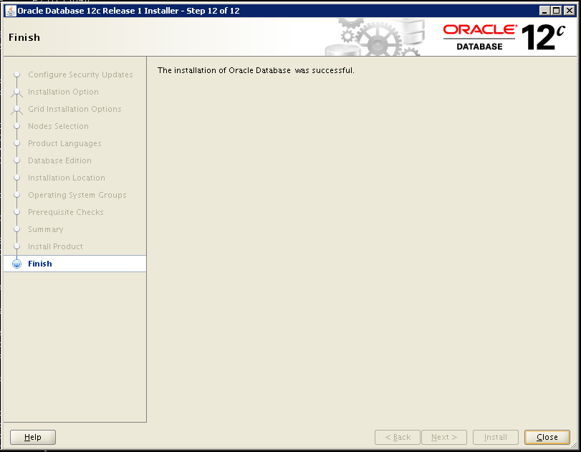

Cluster configuration

After restoration database we can proceed with Cluster configuration.
Adding the database and instance to the cluster by below command.
srvctl add database -db INSISPT -oraclehome /u01/app/oracle/product/12.1.0/dbhome_1/ -spfile +DATA/INSISPT/PARAMETERFILE/spfile.274.1016721065
srvctl add instance -d INSISPT -i INSISPT1 -n e75lrl3045
srvctl add instance -d INSISPT -i INSISPT2 -n e75lrl3046

Post Check
Post check of the Installation and configuration can be done as per below
Check the status of the database
srvctl config database -db INSISPT

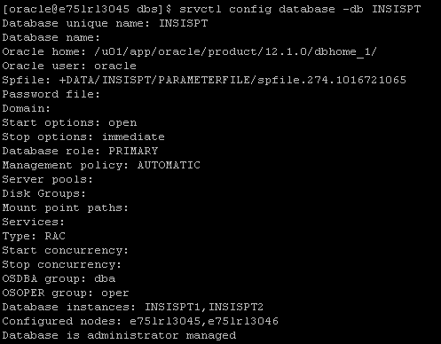

Check the status of all the process in cluster crsctl stat res –t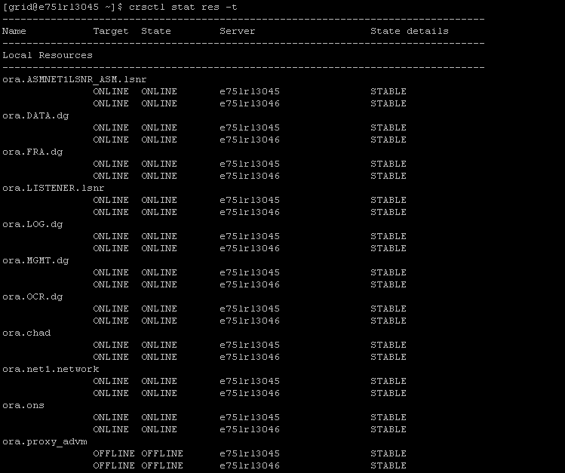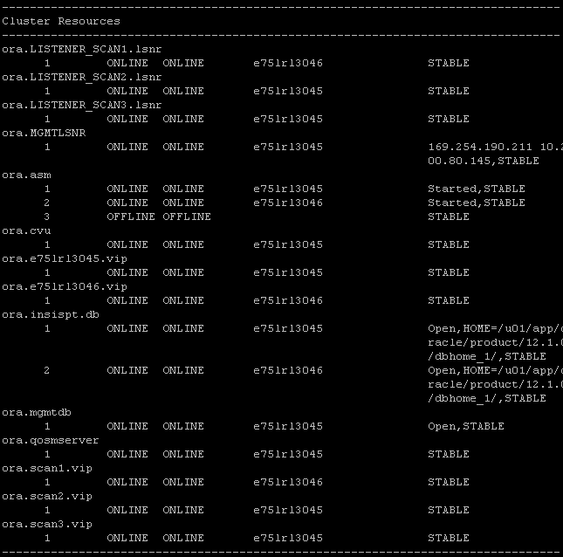

Check the status of scan listener
srvctl config scan

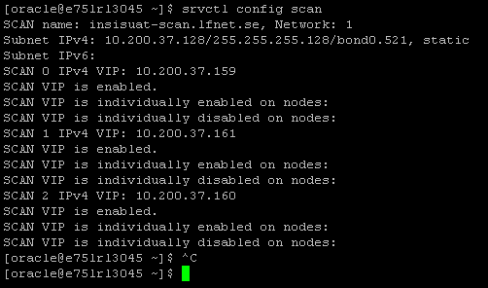

SQL> select database_name,instance_name,open_mode from gv$database,gv$instance;

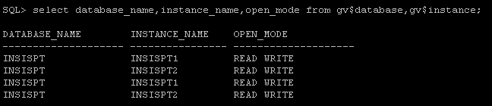

END OF DOCUMENT

